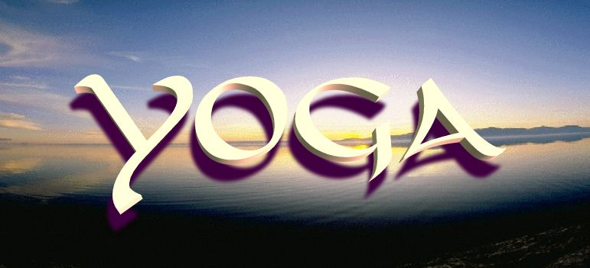

MaryJayne Waddell Yoga at Castaways on the Lake
So happy to announce that our charity for June is the West Webster Fire Department. Come each Monday in June at 9am at Castaways 244 Lake Rd, Webster on the Lake. Help support these wonderful men and women for there service! Even if you don't do yoga you can sit and enjoy our Great Lake Ontario from 9-10am on the deck! STARTS THIS MONDAY!! Send this to friends!

